**Using Slick-JS Library**

The Slick -JS library is useful to create image carousel, to include it in your webpage access the site: https://kenwheeler.github.io/slick/

* First step is to download the slick, and extract the files



We can choose some demos such as:



It is used in responsive webpages



It is used to create a set with different height images.



It is useful to adjust automatically the images height



It is useful to set up how many images will be showed.



It is useful to select random images.

* After downloaded, we need to put the slick-Js after Jqueries



* Remember to include the slick.css and slick-theme.css included within html Head, like image below, you can put the two files inside of main file.





* Include the HTML Markup

<<div class="your-class">

<div>your content</div>

<div>your content</div>

<div>your content</div>

</div>

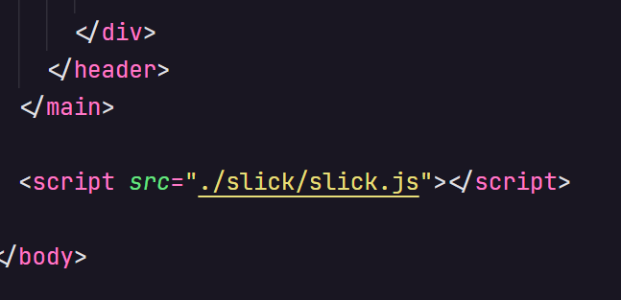

* Here we included the script slick.js before to close the body to make sure of include all the code.



* In this part we used the div to include data-slick with atributtes ‘ slidesToShow and slidesToScroll’ and created the class ‘center’ in the HTML Markup used to refer in CSS and Js like the image below.

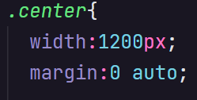

* Here the box was configured to 1200px of width and margin automatic.
* Put the script file inside JS file
* $(document).ready(function(){
* $('.your-class').slick({
* setting-name: setting-value
* });

});

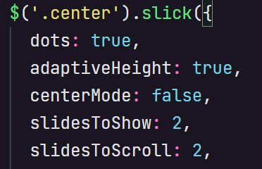

* Dots, correspond dots are used to show how many sets are on the site.



* AdaptiveHeight, indicates the images are adjusted automatically.
* centerMode, is used to contrast the image above other.
* slideToShow and SlideToScroll, indicates how many images will be presented in each set.

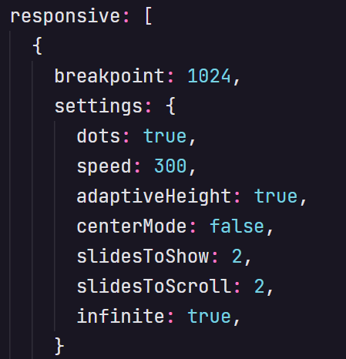

* This part includes the responsive method, which makes the web pages work with adjustable images for computers, tablets and cell phones, using the 'breakpoints', where the value 1024 represents computers, 600 for tablets and 480 for cell phones.
* Included here are the speed of sets, how fast can I change sets, and the infinite method, which accepts seeing sets infinite times.

